

GROUP ASSIGNMENT

**(INDIVIDUAL WORK)**

**CT043-3-1- IN**

**INTRODUCTION TO NETWORKING**

**NAME: SOO JIUN GUAN**

**STUDENT ID: TP068687**

**HAND OUT DATE: 12 JULY 2022**

**HAND IN DATE: 5 SEPTEMBER 2022**

**WEIGHTAGE: 50%**

**INSTRUCTIONS TO CANDIDATES:**

**1 Assignment is to be submitted through online submission (Moodle).**

**2 Students are advised to underpin their answers with the use of references (cited using the APA Name System of Referencing).**

**3 Late submissions will be awarded zero (0) unless Extenuating Circumstances (EC) are upheld.**

**4 Caes of plagiarism will be penalized.**

**5 You must obtain 50% overall to pass this module.**

**Table of Contents**

Introduction 3

Objective 4

Assumptions 5

Floor Plan with Justification 6

Network Diagram with Justification 12

References 17

## **Introduction**

In today’s information age, networks play an important role to share and transport data through a shared medium. People nowadays can enjoy the benefits of texting, telephony, video conferencing, chat rooms, etc. In addition, large organizations also easier to maintain data in an organized manner and facilitate access for desired people. Therefore, Local Area Networks (LANs) are commonly used.

LAN is a network that interconnects computers within a restrict area. A LAN can be small or large, ranging from a home network with one user to an enterprise network with thousands of users and devices in an office or school.LAN can share devices with anyone in the same network. It is useful to economize the purchase of hardware. The exchange of data or information can also do speedy because of the high data transfer rate. Thus, it is the best choice to use on the whole campus.

The main branch of Global Metric International School based in Melaka since year 2013. CEO of Global Metric has determined to expand business with establish another new branch for secondary school in Seremban. This assignment aims to design an appropriate network and then provide a complete network to implement for the new campus.

## **Objective**

The major objective of this assignment is to propose a reasonable topology diagram with necessary network devices and IP addressing scheme to plan for a suitable network design and floor plan to make the new campus work properly. Findings and outcomes of the research should be arranged in a proper flow to be presented to the technical team who is involved in the full design of the network, which can make it easy for the CEO of Global Metric International School to refer.

In addition, the research effort uses Cisco Packet Tracer is used as a proof of concept because it is effective and works well in network experimentation. Although it simulates the real environment, it is actually no different from it. Besides that, it makes researchers easier to check their mistakes.

In the proposal, the new infrastructure must include two buildings, called Vista Court A and Vista Court B. Each of these new buildings consists of two floors as well as is equipped with necessary facilities.

## **Assumptions**

The functions of these two buildings in Seremban are clearly defined, which are divided into academic area and administrative area. Both of the blocks transport data to each other via routers.

CCTVs are installed as oversee various areas to avoid disclosure of important information. Moreover, there is WIFI covering the whole building to associate all sectors for being able to convey information. The entire building is connected by a bandwidth which no less than 100Mbps. This can effectively enhance work efficiency of the staff and they can communicate smoothly. The installation of aircons is to maintain air circulation, and enable staff can work in a good condition. The other purposes are to prevent servers from overheating for a long time and ensure the servers can be working stably without any stuck and stopped. RFID system also has been installed for some places that need protection, only certain staff can access.

As a consequence, the prospect of this new school will be better than the main branch due to their complete facilities.

## **Floor Plan with Justification**

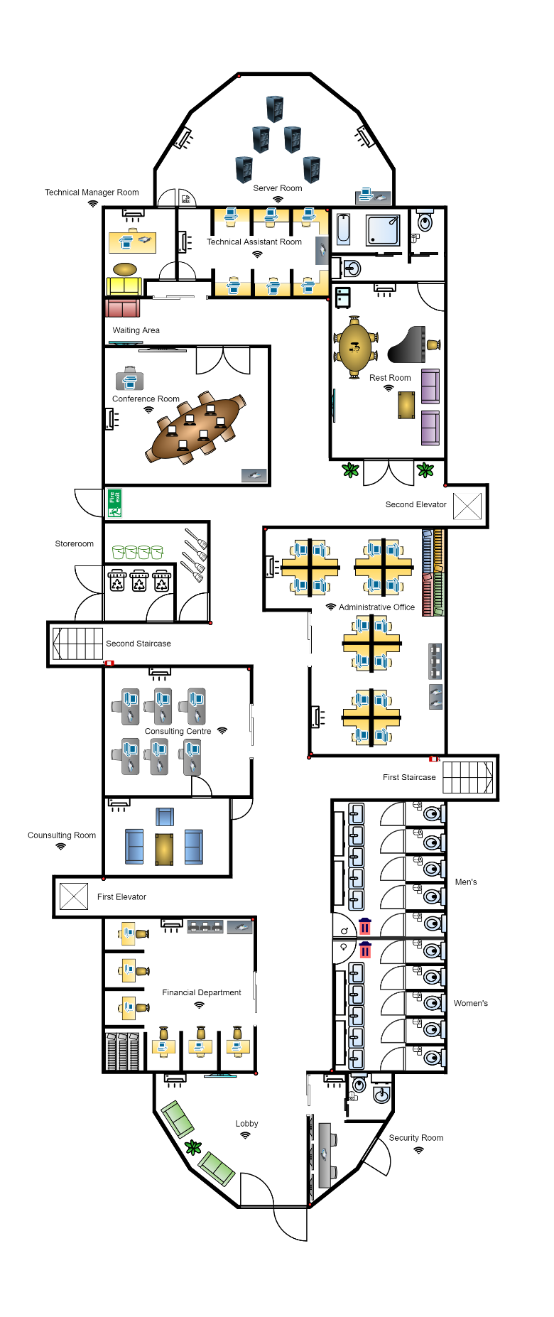

*Figure 1: Vista Court B 1st Floor (Floor Plan)*

|  |  |
| --- | --- |
| Symbol | Description |
|  | Air Conditioner  Computer  Laptop  Printer  VoIP Phone  CCTV  RFID Reader  Television  Server |

*Figure 2: Legends*

The first floor of Vista Court B is the administrative area that provides for somebody to work or handle academic affairs. After entering main entrance, there is a **lobby** to welcome and direct someone who comes to this building. The following devices are in the lobby:

1. One Aircon

2. One TV

On the right side, it is a **security room** that can ensure the staff and students' privacy and safety to prevent criminal activities. A toilet is available in the security room as security guards can get back to their jobs speedier. In addition, there is an exit to facilitate inspection of the outside for the security guards. The security room has the following devices:

1. One Aircon

2. One VoIP Phone

3. One CCTV

After leaving the lobby, there are **gender toilets** on the right side.

Opposite of the toilets block, it is a **financial department** that can solve any financial issues including salary and school fees. The following are the devices in the financial room:

1. One Aircon

2. One VoIP Phone

3. Six Computers

4. One CCTV

5. Three Printers

Besides the financial room, it is a **consulting room** that provides anyone who needs private consultation with a comfortable environment. The **first elevator** is located between the financial room and the consulting room, and it can directly reach the second floor. The consulting room provides the following devices:

1. One Aircon

3. One Smartphone (for counsellors)

Next to the consulting room is **consulting centre** that offers students to have psychological counselling or further education. It is also worth mentioning that there is a door which leads to both of these rooms. There are two **staircases** by side and in front of the consulting centre. The available devices are shown below:

1. One Aircon

2. Six VoIP Phones

3. Six Computers

4. One CCTV

Furthermore, **administrative room** is opposite the consulting centre. Paperwork will be done here to keep the school operating properly. The following devices are provided:

1. Two Aircons

2. Two VoIP Phones

3. Sixteen Computers

4. Two CCTVs

5. Three printers

**Storeroom** is beside the staircase. There are cleaning tools prepared to make sure the campus is clean and tidy. There is a small room at angle of the storeroom to save garbage and release it through the door which leads outside.

Additionally, there is a **conference room** apart from the storeroom, which provides a suitable place for the staff’s daily meetings. The devices in this space are listed below:

1. One Aircon

2. One VoIP Phone

3. Six Laptops

4. One Computer

There is a **restroom** across from the conference room. Staff can have some entertainment activities in the restroom during their free time and then have a bath to relieve their stress. After going out of the restroom, there is **second elevator** on your left side. The following devices are available in the restroom:

1. One Aircon

2. One TV

At the end of 1st floor, it is a **server room** that stores data and is protected by an RFID system, which only specific staff can access. The server room is required to have:

1. Two Aircons

2. One VoIP Phone

4. One Computer

5. One CCTV

6. Five Servers

7. One RFID Reader

There are **technical manager room** and **technical assistant room** outside of the server room, therefore must pass through technical department if go to the server room. In addition, it is a **waiting area** in space outside the technical department. The technical department has the following devices:

1. Two Aircons

2. Two VoIP Phones

3. Seven Computers

4. One CCTV

## **Network Diagram with Justification**

Vista Court B 1st Floor (Note: some areas do not show all devices due to too many)

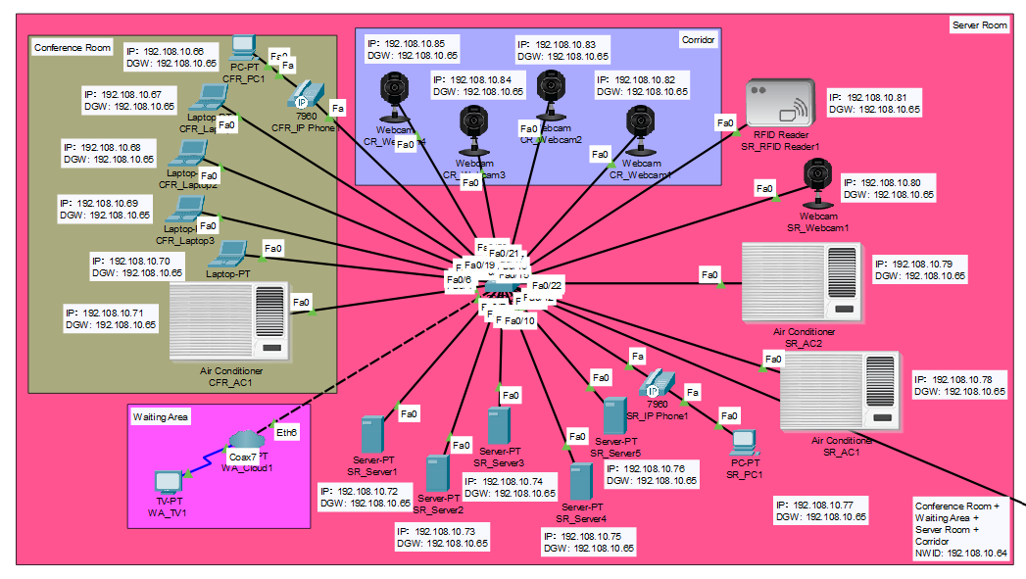

*Figure 3: Vista Court B 1st Floor Network Layout (CFR + WA + SR + CR)*

Figure above has shown network diagram of conference room, waiting area, server room, and corridor. Devices of all these spaces are connected to one switch by using copper straight through cable. For **conference room**, there is a VoIP Phone (CFR_IP Phone1) which is connected to a computer (CFR_PC1) used to contact another department. Laptops and aircon (CFR_AC1) are provided in the conference room for staff. In addition, **waiting area** isprovided with a TV (WA_TV1) to watch and then wait for someone. Servers (SR_Server1, SR_Server2, SR_Server3, SR_Server4, SR_Server5) which can store data and VoIP Phone (SR_IP Phone1) are equipped in **server room**. Some necessary facilities are available in this space such as aircons (SR_AC1, SR_AC2), CCTV (SR_Webcam1), and RFID Reader (SR_RFID Reader1). Besides that, many CCTVs are configured in **corridor** to improve comprehensive security management and it is useful to resolve the case.

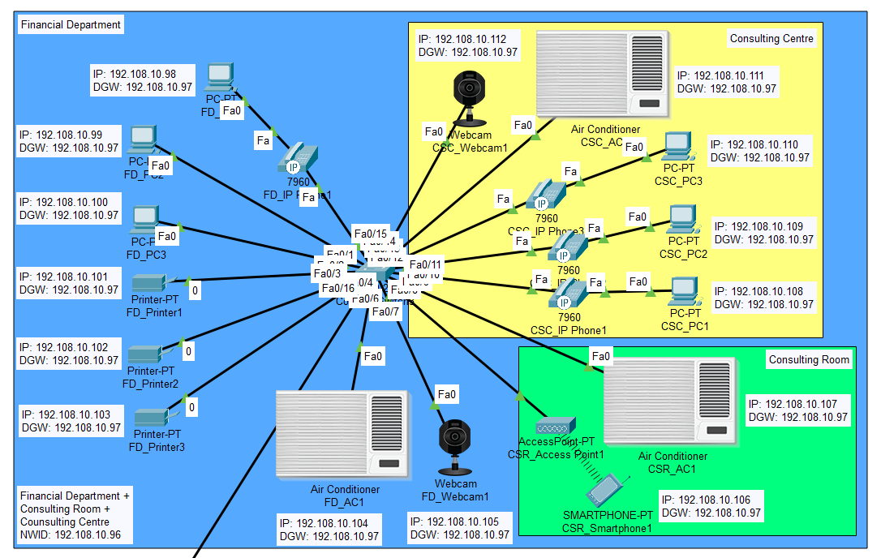

*Figure 4: Vista Court B 1st Floor Network Layout (FD+CSR+CSC)*

Figure above has shown network diagram of financial department and consulting area. For **financial department**, computers and printers (FD_Printer1, FD_Printer2, FD_Printer3) which are basic facilities of office can be found. Each of the computers (FD_PC1) connects with VoIP Phone (FD_IP Phone1) and CCTV (FD_Webcam1) is also installed in order to keep in touch and ensure staff’s safety. Moreover, smartphone (CSR_Smartphone1) is required in **consulting room** to have a secret conversation with someone who dials up. There are three VoIP Phones (CSC_IP Phone1, CSC_IP Phone2, CSC_IP Phone3) which are connected with three computers (CSC_PC1, CSC_PC2, CSC_PC3) separately and CCTV (CSC_Webcam1) in **consulting centre**. Aircons (FD_AC1, CSR_AC1, CSC_AC1) are configured in these three spaces to work in a comfortable environment. All of these devices are connected to one switch.

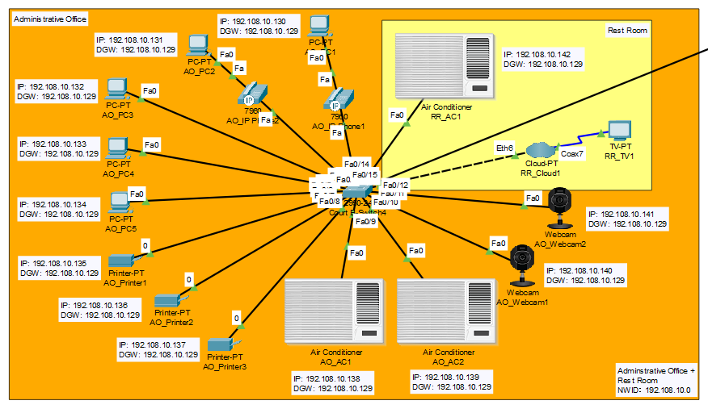

*Figure 5: Vista Court B 1st Floor Network Layout (AO+RR)*

Figure above has shown network diagram of administrative office and rest room, devices in these spaces are connected to a switch. For **administrative office**, computers and printers (AO_Printer1, AO_Printer2, AO_Printer3) are available in this space to handle online problems or do paperwork. Additionally, aircons (AO_AC1, AO_AC2) and CCTVs (AO_Webcam1, AO_Webcam2) are also equipped in the administrative office. TV (RR_TV1) in **restroom** is connected to switch through an intermediary called cloud (RR_Cloud1), as well as aircon (RR_AC1) and other facilities which are mentioned above use copper straight through cable to connect to the same switch.

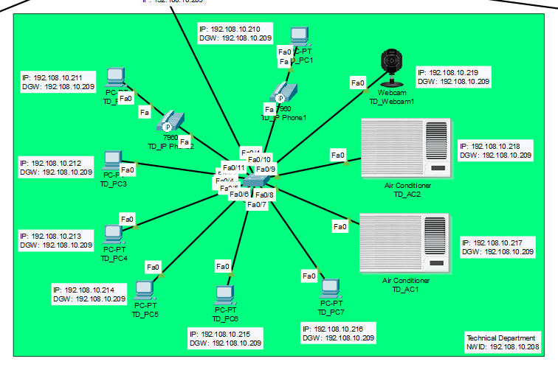

*Figure 6: Vista Court B 1st Floor Network Layout (TD)*

For **technical department**, it is filled with seven computers, two of them (TD_PC1, TD_PC2) are connected to VoIP Phones (TD_IP Phone1, TD_IP Phone2). Aircons are installed in this space to keep the department’s temperature lower. Furthermore, CCTV (TD_Webcam1) is configured in technical assistant room to ensure their safety and monitor them. All devices in this department are connected to one switch.

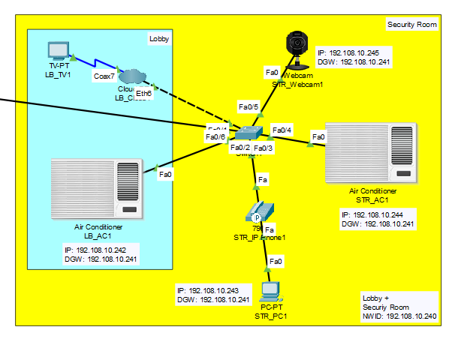

*Figure 7: Vista Court B 1st Floor Network Layout (LB+STR)*

Figure above has shown network diagram of lobby and security room, a switch is used to connect all devices in the same network. **Lobby** is provided with a TV (LB_TV1) which can show videos about the new campus. There is a VoIP Phone (STR_IP Phone1) connected to a computer (STR_PC1) in **security room** for communication. In addition, CCTV (STR_Webcam1) is installed to record who enters the security room. Both of these spaces are configured with aircons (LB_AC1, STR_AC1).

## **References**

1. *What Is a LAN? Local Area Network*. (n.d.). Cisco. Retrieved August 31, 2022, from https://www.cisco.com/c/en/us/products/switches/what-is-a-lan-local-area-network.html

2. *Local area network*. (2022, September 1). Wikipedia. Retrieved September 1, 2022, from https://en.wikipedia.org/wiki/Local_area_network

3. Helena Sampayo. (2021, March 1). *The Most Popular Office Facilities in 2020*. Hubble. Retrieved September 1, 2022, from https://hubblehq.com/blog/the-top-10-most-searched-for-office-facilities